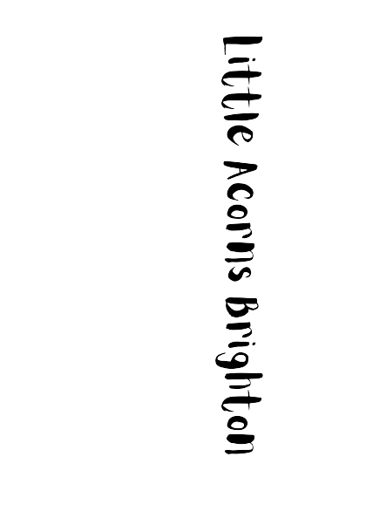


EYFE Funding – Term time only

We understand how stressful organising childcare finances can be, so we also offer term time only. If would like to see what your tailor-made fee plan would look like, then please email Bex at brightonlittleacorns@gmail.com with the details of the sessions or hours you are wanting to take.
We understand how stressful organising childcare finances can be, so we accept EYFE funding across our full year. If would like to see what your tailor-made fee plan would look like, then please email Bex at brightonlittleacorns@gmail.com with the details of the sessions or hours you are wanting to take.
When and how your child can access EYFE will depend on whether the child and/or your family meet eligibility criteria.
Children aged between 9 months and 2 years
Children can access EYFE for Working Families from the term after they turn 9 months old if your family meet the criteria for EYFE for Working Families. If approved, your child can access up to 30 EYFE hours per week.
Children aged 2 years
2 year olds can access EYFE for Working Families for up to 30 hours per week. If your child was eligible for EYFE for Working Families between 9 months and 2 years, your child can continue to access EYFE for Working Families after turning 2 years old if your eligibility code is renewed.
2 year old EYFE is available from the Local Authority for children and families who meet different criteria (Receipt of certain benefits, Looked After Children or previously Looked After Children, Children with an Education, Health and Care Plan (EHCP). They could access up to 15 hours EYFE per week from the term after they turn 2 if they are eligible. Families who are eligible for both 2 year old Local Authority Issued EYFE and EYFE for Working Families can access up to 15 hours per week of each, totalling up to 30 hours per week.
Funding Codes
All eligible parents will receive an 11-digit eligibility code which must be shared with the nursery and reconfirmed every three months where applicable. Funding can be split between more than one provider.
Term-Time only 15 hour offer
For families accessing 15 hours per week, this is available for the 38 weeks of term time each year.
EYFE does not cover the costs of meals, consumables, and additional extras, so at Little Acorns we have a voluntary charge per session for these additional items.
Additional charges per half day:
£4.50 Morning snack & lunch (morning session) or Afternoon snack & dinner (afternoon session)
£3.50 Suncream, creams, lotions, wipes, tissues, nappies

If you do not wish the nursery to provide these extras then please speak to us and we will advise on items which need to be provided to the nursery.

Term-Time only 30 hour offer
EYFE does not cover the costs of meals, consumables, and additional extras, so at Little Acorns we have a voluntary charge per session for these additional items.
Additional charges per half day:
- £4.50 Morning snack & lunch (morning session) or Afternoon snack & dinner (afternoon session)
- £3.50 Suncream, creams, lotions, wipes, tissues, nappies

If you do not wish the nursery to provide these extras then please speak to us and we will advise on items which need to be provided to the nursery.

The Small Print

- Our fees are payable calendar monthly in advance by direct debit, tax-free childcare, bank transfer or nursery voucher before the 1st of each month.

- Our sessions are 8am-6pm for a full day; 8am-1pm for a morning session; and 1pm-6pm for an afternoon session.

- Your weekly fees will be converted to a calendar monthly amount so there is one payment coming out each month.

- If you are paying by voucher then please let us know the company you are using and ensure that your child’s name is used as the reference when the payment is made. If the voucher does not cover the entire fee, then any balance will be collected by direct debit. Please remember that both parents / carers are entitled to redeem the voucher.

- Tax-Free Childcare – our nursery can accept payments from this funding system scheme. More information can be found here: https://childcare-support.tax.service.gov.uk/par/app/applynow

- In order to book a place at our Nursery please contact us for a Registration Form and we will advise you of the fees.

- For fee-paying places, a holding fee of 50% deposit of one month’s fee will be payable – with the remaining 50% paid upon starting. This deposit will be used to pay your final month with us, should you give the required notice period of one calendar month.

- There is a minimum booking commitment for all children aged 0 to 5 years of 4 half days or 2 full days. Bookings must be for the same session(s) each week and as previously mentioned, appropriate notice must be provided for any changes.

- Extra sessions can either be paid for on the day or collected with the following month’s invoice. Credit cards are accepted for extras payments. Extras are for additional sessions or additional hours and subject to availability.

